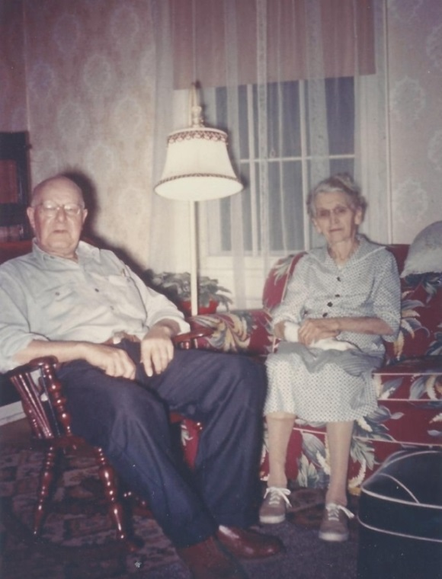

Floyd & Minnie Foster Hickle, Mary Helen Foster

Wolfe’s mother and step-father - Jan 1964

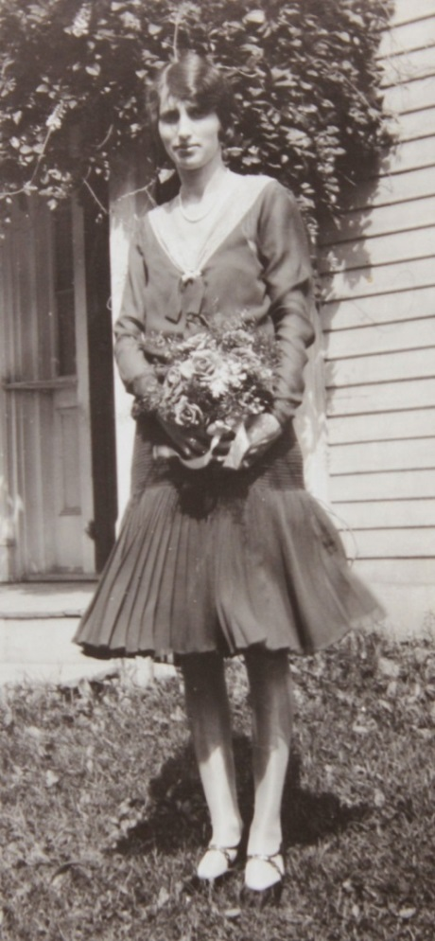

**Mary Helen Foster Wolfe**

**on her wedding day - 15 Jun 1929**